Get Diff
We can use the git diff command to view changes between commits, branches, files, our working directory and more.
We often use git diff alongside commands like git status and git log, to get a better picture of a repository and how it has changed over time.
Without additional options, git diff lists all the changes in our working directory that are NOT STAGED for the next commit.
git diff HEAD: list all changes in the working tree since your last commit
git diff --stage
git diff --cached
- Will list the changes between the staging area and our last commit
- “Show me what will be included in my commit if I run git commit right now”

Diff-ing Specific Files
git diff HEAD <filename>
git diff --staged <filename>
- We can view the changes within a specific file by providing git diff with a filename
  - git diff commit1..commit2
  - git diff branch1..branch2

Comparing Files
For each comparison, Git explains which files it is comparing. Usually this is two versions of the same file.
Git also declares one file as “A” and the other as ”B”

Chunks
A diff won’t show the entire contents of a file, but instead only shows portions or “chunks” that were modified.
- A chunk also includes some unchanged lines before and after a change to provide some context.

Git Diff Output
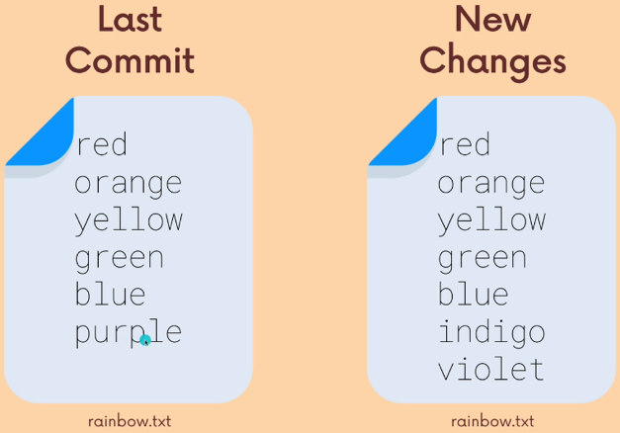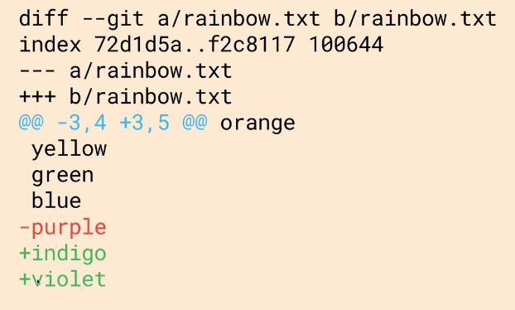
diff --git a/rainbow.txt b.rainbow.txt
- First line - shows the files being compared
  - Usually it’s the same file: Version a vs Version b
index 72d1d5a,,f2c8117 100644
- (Not very important) Metadata about the files being compared, each file gets its own hash and the second string is an internal file mode identifier.
--- a/rainbow.txt
+++ b/rainbow.txt
- file a was the original file while b has the changes added.
@@ -3,4, + 3,5 @@ orange
yellow
green
blue
-purple
+indigo
+violet

Chunks
- @@ -3,4 +3,5 @@
- Each chunk starts with a chunk header, found between @@ and @@
- It’s not negative 3 (-3) the - indicates file a, as with + it is not what is added but what is changed from file b
  - From file a, from line 3, 4 lines are extracted
  - From file b, from like 3, 5 lines are extracted

Every line that changed between the two files is marked with either a + or - symbol.
- Lines that begin with - come from file A
- Lines that begin with + come from file B

Comparing Between 2 Branches
git diff main..odd-numbers
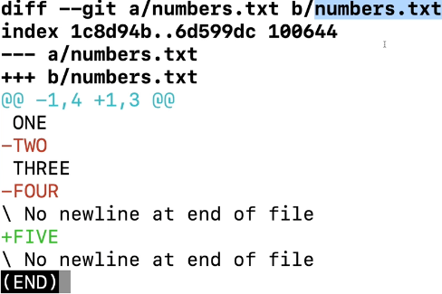
diff --git a/numbers - main branch
b/numbers.txt - odd-numbers branch
- Because of how it was written git diff main(a)..oddnumbers(b)
Flipping The Syntax
git diff odd-numbers..main
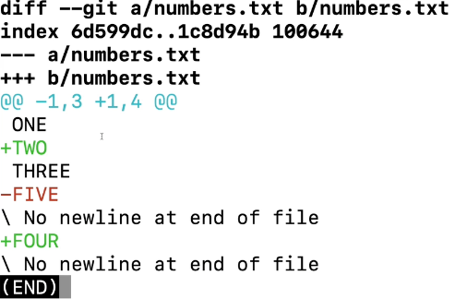
git diff odd-numbers main
git diff odd-numbers..main

Comparing Between 2 Commits
Take the commit hash
git diff 4a9da7b..2912870
